(12.3 pt. 3 line spaces for the first page)

Writing Guide and Format for Manuscript (Arial 15 pt.)
(12.3 pt. line space)
Hikaru TAIYO^{*1} Mitsuru FURYOKU^{*2‡} Atsuko HINO^{*3} John SMITH^{*4} (Times New Roman 9 pt.)
(12.3 pt. line space)
Abstract (Times New Roman 12 pt., bold)
This document provides writing guide and format for preparing a research paper, a technical paper and a short report of the Journal of Japan Solar Energy Society in English on A4 sheets using your computer. Follow the specifications in this document to determine the layout of your manuscript’s pages. The abstract should begin with 5 blanks and also be center of the printing areas with the indents of 12.5 mm for each side. The preferred spacing to the next heading is one line space (Times New Roman 9 pt.).
(12.3 pt. line space)
Keywords: Technical paper, Layout, Margins, References (Times New Roman 9 pt., “Keywords:” is bold.)
(12.3 pt. line space)

(12.3 pt. line space)

1. Introduction (Times New Roman 10 pt.)
(12.3 pt. line space)
Follow “Instruction for authors” to prepare a research paper, a technical paper and a short report. For the other articles, also follow the instruction, but you can omit abstract and keyword.
Use A4 paper, and make margins listed in table 1. Space between columns is 7.5 mm.

Table 1 Margins for A4 page layout.
Top | 27 mm
Bottom | 22 mm
Left | 20 mm
Right | 20 mm
Space between columns | 7.5 mm

2. Title

Place 12.3 point 3 line spaces at the beginning of the first page, then write title in 15 point Arial.

3. Authors

Place a line space and write author(s) in 14 point Times New Roman.

4. Abstract

Place a line space and write “Abstract” in 12 point bold Times New Roman, then align center. Start a new line, put 10 mm indentation for the first line, and start abstract. Approximately 150 and 100 words for research and technical papers, and for a short report are recommended respectively. Use full justification for the abstract with 10 mm indent from both right and left side.

5. Keywords

Place 12.3 point line space, and write 5 keywords approximately. Then, place 12.3 point line space after the keywords.

6. Affiliation of Authors

Write the affiliations of the authors as a footnote of left column. As for the corresponding author, who are indicated with double dagger‡ at the author’s list and should be one of the members of JSES, the title, address and e-mail address should be added. Place line spaces for the date of manuscript received and manuscript accepted, which will be added by the JSES secretary office.

7. Main Text

Use 9 pt. and justify for main text in 2 columns and 57 lines for both columns in a page. And put 10 mm indentation at the first sentence of the paragraph.

7.1 Headings for chapter, clause and section

Use Times New Roman bold and left-align for all headings. Place a line spaces before and after a chapter heading, and before a clause heading. No line space should be placed before a section heading, and write text after four blank spaces. Numbering and text style should be as follows.
*1 Graduate School of Engineering, Sunrise Univerity
*2 Assistant Professor, Faculty of Engineering, Sunrise University, 1-1 Sunset hills, Hinode-shi, Tokyo 100-9999, Japan
‡e-mail: mitsuru@hinode-u.ac.jp (Times New Roman 8 pt.)
*3 Central Research Institute, Blue sky electricity Co., Ltd.
*4 Professor, Faculty of Engineering, Sunrise University
Received: dd mmmm yyyy, Accepted: dd mmmm yyyy

(1) Chapter heading (10 pt. bold): 1., 2., …

(2) Clause heading (9 pt. bold) : 1.1, 1.2, …
(3) Section heading (9 pt.): 1.1.1, 1.1.2, …

7.2 Items
Items should be listed with numbers in a closed bracket.
(1) Use 9 pt. text size.
(2) Use Times New Roman.

7.3 Numbering of equations
Use serial number in a closed bracket, and put it at the right end of the line.

7.4 Page numbers
Put page numbers at the bottom center of each pages using footer.

8. Figures, tables and photos

Size of figures, tables and photos should fit the columns in principle, and place one line space before and after the figures as shown in Fig. 1. Do not write main text at the sides of them.

8.1 Captions and numbering
(1) Write captions expressing appropriately by using the same font and font size of main text. Figure captions should be below the figures, and table captions should be above the tables.
(2) Use abbreviation and numbers for captions as below.
Fig. 1, Fig. 2, …; Table 1, Table 2, …
(3) Explanations of figures and tables are mandatory. They should be written in main text, and/or in figures if there are special needs.
(4) Use similar size of font for legends and axis labels.

8.2 Matters that require attention to figures and tables
(1) Use appropriate and important figures (including photos, same as above) and tables only.
(2) Printing is black and white in principle, therefore, take care to draw figures.
(3) Figures and tables should be camera-ready master.
(4) Photos should be monochrome in principle. Color photos can be printed with additional expenses.
(5) Only clear figures, tables and photos will be accepted.

9. Sentence Style, Technical Term and Unit

9.1 Sentence Style
(1) Use academic style.
(2) Name of an era should be the Christian Era in principle.

9.2 Technical term
Technical term should be based on JIS, ISO, IEC, ISES, and so on.

9.3 Units and physical quantity
(1) Use units of the International System of Units (SI Units), and use unit symbol defined by JIS Z 8203 or ISO 1000.
(2) Symbols indicating physical quantity should be italic. Unit should be identifiable by using bracket, space, etc., and should not be italic.

10. Acknowledgement

Acknowledgement could be placed before the references on your needs. Write it simply and properly without advertisements. Any conflict of interest should be noted.

11. References

Make appropriate references that are related to your research work regarding research background and previous studies that could show the novelty, originality and validity of your manuscript with neither deficiency nor excess.

11.1 Citation
(1) References in the main text should be cited with serial numbers in closed brackets using superscript e.g., previous studies^{(1, 2)}, or previous studies⁽¹⁻³⁾.
(2) Cited literatures should be listed and numbered at the end of the manuscript.
(3) Name of authors more than 5 could be omitted.

11.2 Example of references

11.2.1 Periodical: Author(s), Title, Name of journal, Volume (Number), Page (Published year).
1) S. Yoshida, H. Yamada, Curve Plot of Direct Irradiance Condition, Journal of Japan Solar Energy Society, 9 (6), 3745–3751 (1983)．
2) K. J. Cathro, D. C. Constable and T. Solaga, Durability of Porous Silica Antireflection Coatings for Solar Collector Cover Plates, Solar Energy, 27 (6), 491–500 (1981).

11.2.2 Book: Author(s)/Editor(s), Name of book, Volume (Omitted if 1 volume only), Page (Published year), Publisher, Published place.
1) J. A. Duffie and W. A. Beckman, Solar Engineering of Thermal Processes，54–55 (1991), John Wiley & Sons, New York.
2) A. A. M. Sayigh (ed.), Solar Energy Engineering, 255–256 (1977), Academic Press, New York.

11.2.3 Papers from conference proceedings: Author(s), Title, Name of conference proceedings, Number (Month Year), Page, Place of conference.
1) B. Window, D. R. McKenzie, G. L. Harding and A. R. Collins, The Sydney University Evacuated Collector Program, Proc. 1979 ISES Conf. (Mar. 1980), 87, Perth, Australia.
2) D. C. Beekley and G. R. Mather, Analysis and Experimental Tests of Solar Collector Arrays Based on Evacuated Tubular Solar Collectors, Ext. Abstr. 1975 ISES Conf. (Aug. 1975), 20, Los Angeles, California.
3) T. Yamada, J. Tanaka, K. Oyama, I. Sato, Experimental Study of Cool Tube (1), JSES/JSWS Joint Conference (1995), 115, Tokyo．
4) E. C. Boes，Fundamentals of Solar Radiation, Rep.SAND79-0490 (Dec. 1979), Sandia National Laboratories, Albuquerque, New Mexico.
5) W. K. Smith, Thermodynamic Properties of Ammonia-Water Solution, Ph.D. Thesis, University of Arizona (1966), 49–53，Phoenix, Arizona.

11.2.4 Website: Avoid citing website and contents on the website whose author is anonymity or not clear in principle. If unavoidable, only academic societies, public organizations and trusty organization can be accepted. The citation should include month and year of visited day in a closed bracket and URL. Omit the period at the end of the citation not to confuse citation with the URL.
1) JSES, Writing Guide and Format for Manuscript (Nov. 2014),
http://www.jses-solar.jp/ecsv/front/bin/ptdetail.phtml?Part=m02-p002&Category=2935

12 Abridged translation
Abridged translation in Japanese (2 pages) can be attached. The abridged translation consists of title, authors, keywords, affiliation of the authors and abridged main text. It should not include abstract, figures, tables, references, acknowledgement, etc.

13 Others

13.1 Application of manuscript submission
Fill the manuscript submission slip with correct information. Incomplete information about submission capacity, non-duplicate publication, contact address(es) and area of research field may especially cause a delay of the reviewing process.

13.2 Inquiry
Author(s) can inquire of the JSES secretary office the state of the manuscript in reviewing process.

Enacted on Dec. 6th, 1977
Revised on May 14th, 1984
Revised on Jan. 31st, 1989
Revised on Mar. 12nd, 1996
Revised on Nov. 6th, 1997
Revised on Mar. 1st, 2000
Revised on Sep. 14th, 2001
Revised on Jan. 31st, 2015
Revised on Jan. 12nd, 2017
Revised on Sep.12th, 2017

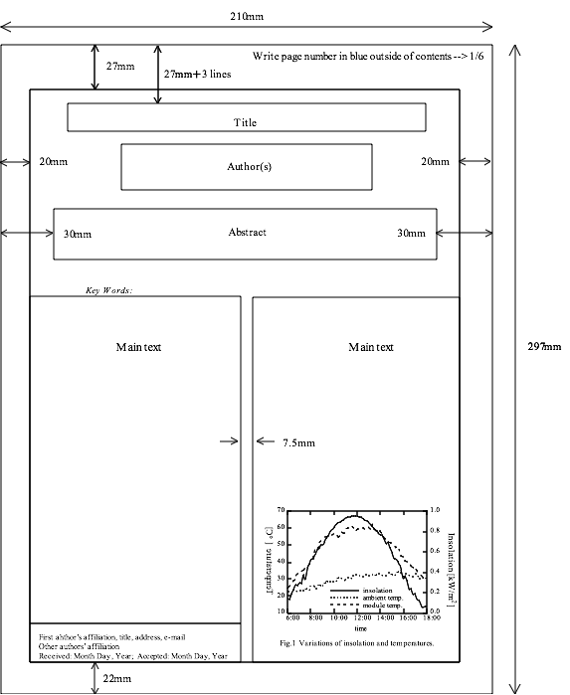
図1

Fig. 1 Layout of the first page of a manuscript.
_{著者所属･役職･住所・学位(和文，英文)}
_{24mm}

